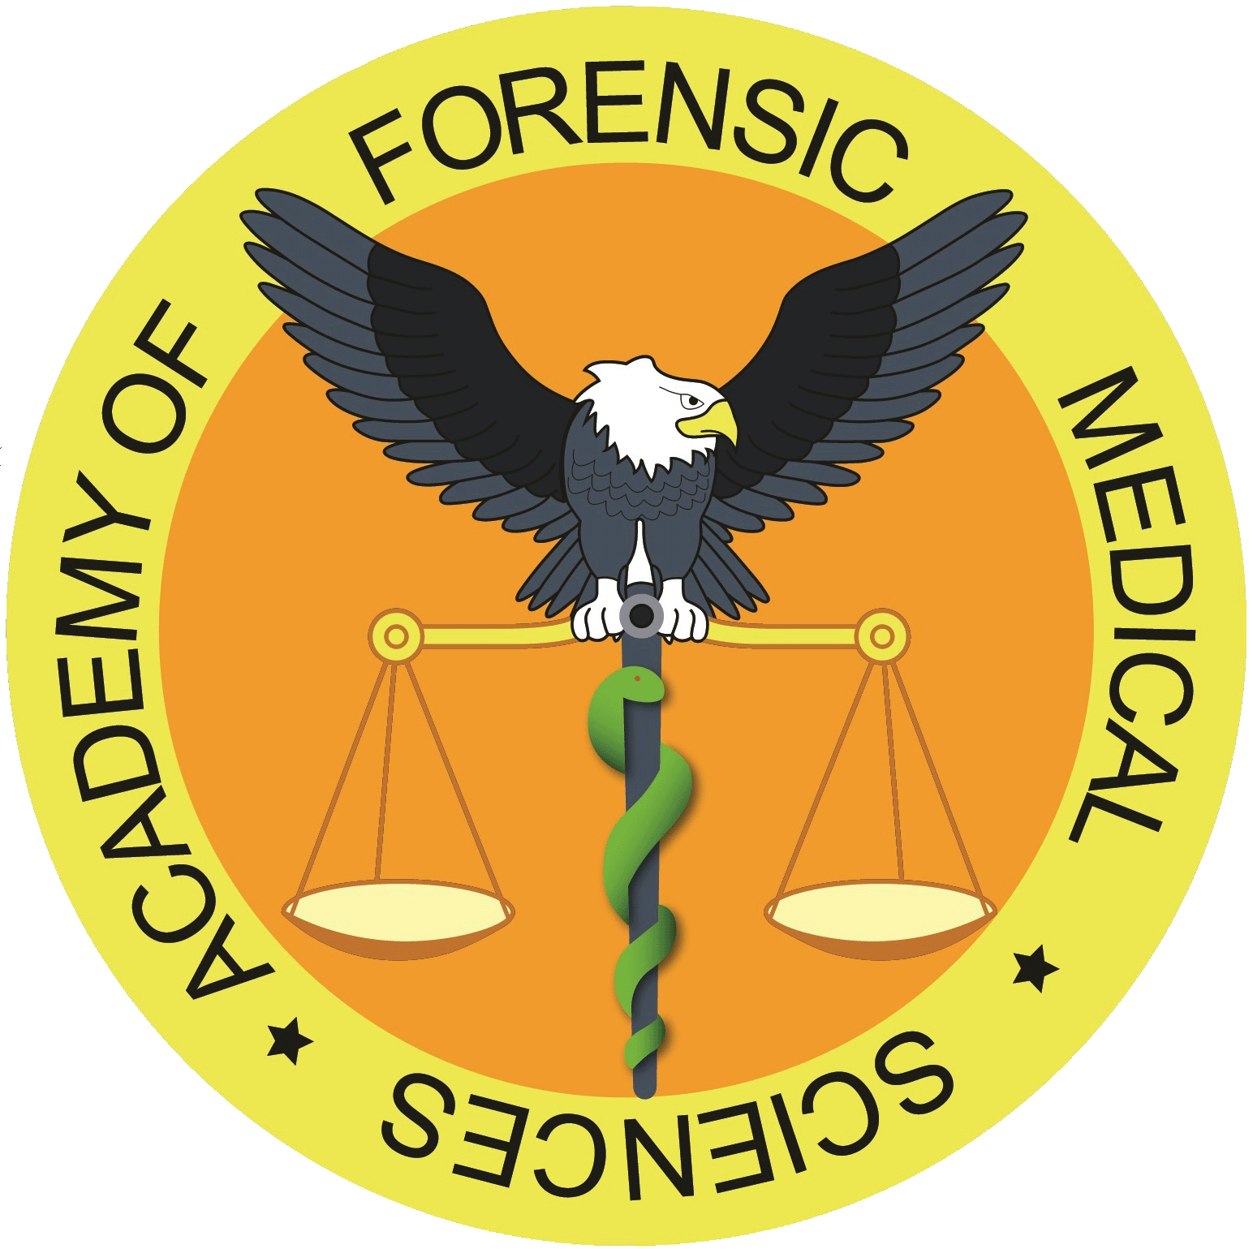

CPD COURSE/ EVENT ACCREDITATION APPLICATION PROCESS

Assessment for approval will be based on number of criterias. All event applications must meet the points mentioned below:
- Target audience, benefits to participants and aims of the event should be clear.
- Details about teaching method should be included.
- Feedback forms, their distribution and collection should be stated clearly.
- The event must not be less than 1 hour’s duration, but may be of one day’s duration, a few days, or be run part time over several days.

Event organisers should ensure that the event fulfils the requirements for approval and that this is evident from the application. If successfully approved, events will be advertised on the Academy of Forensic Medical Sciences Events webpage.
Approved events may not be badged as “accredited”, Approved events may use the following statement in their publicity: “Approved by the Academy of Forensic Medical Sciences for purposes of CPD, this event may be counted as x CPD points”.

Application Fees
All fees are based on 1 hour of lecture-tutorial / 1 CPD point
Unique / one off event: £45 per point / 1hour
Half day: £180
Full day: £360

For Charities:
One off event / all day: £45

Recurrent events (i.e. every 3 months)
For 1-hour lecture: £25
Half day event: £100
Full day event: £200

Bank details can be provided via the invoice for online applications. For postal applications, cheques should be made payable to the Academy of Forensic Medical Sciences.

Application Process
The completed application form, supporting documents and payment for assessment should be submitted to the Academy not less than 28 days before the date of the event, for which approval is sought. Additional information from the provider may be attached to the application form or put in a covering letter but applications cannot be processed without receipt of the fee, which is non-refundable. Applicants must inform the Academy if they have, or intend to, submit their event to any other accrediting authority.

Academy of Forensic Medical Sciences -2. Liability Disclaimer
An approved event may be an activity of merit to the development needs of participants; the Academy is however, not responsible if the specific needs of the participants are not met. Organisers must not at any time, either specifically or generally state or imply that this is the case. The Academy has no liability to an applicant for the approval, or otherwise, of an event.

Guidelines for CPD Accreditation Application

Description and Brief Synopsis
This should be concise and simply written to give a flavour of both the content and the learning experience of the training delivered.

Aims and Objectives
These should be presented as a series of bullet points describing the aims of the training (what it is intended to provide for participants in general terms) and objectives (the actions that will be undertaken to meet these aims, in principle in measurable terms). This should include a reference to any skills and competencies that the event delivers and assesses.

Suitability
Who is the training likely to be most suitable for? Which level of participant is the event most aimed at?

Areas of Specialism / Discipline
Please indicate if the training will appeal to a particular range of participants or professions and provide a brief explanation.

- Recurring Event
It is vital that the Academy of Forensic Medical Sciences is informed if the event has previously received CPD accreditation within the same calendar year.

Course Materials/Resources
These should describe how the expected outcomes will be achieved and through the training/learning styles adopted. Provide a brief explanation of the intended resources and facilities available to participants completing this event.

Delivery Methods
The type of training that is delivered to participants varies from provider to provider. This section of the form will allow providers to specify the type of training and format that will be delivered. Most the common types of training have been mention, however, if the type of training that will be delivered is not specified, please state this in the text box provided. Please note that distance learning includes; Online courses, Webinars (seminars streamed live via a website), recorded seminars/lectures/training sessions for DVD distribution.

