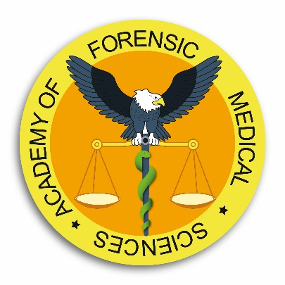

Diploma course in Forensic Human Identification

29 May – 30 June 2023

Lecture 1 | Identification of the non–decomposed cadaver in the mortuary and of the body at different stages of decay – role of the Pathologist
Lecture 2 | Legal issues in the identification of a body
Lecture 3 | Psychological concepts involved in facial recognition
Lecture 4 | Identification from Crime Scene Investigation
Lecture 5 | Clandestine graves including mass graves – Methods of Discovery
Lecture 6 | Methods used when exhuming clandestine graves
Lecture 7 | Gait analysis in identification
Lecture 8 | Presentation and evaluation of identification evidence (Scientists’ perspective)
Lecture 9 | Dating skeletal remains, age, race, sex determination
Lecture 10 | Personal identification from skeletal remains
Lecture 11 | The Humanitarian perspective of Forensic Human Identification – observations and recommendations from the International Committee of the Red Cross
Lecture 12 | Forensic Podiatry
Lecture 13 | Mass disaster management – the role of the SIM
Lecture 14 | Evaluation of identification evidence (Legal perspective)
Lecture 15 | Identification by voice recognition
Lecture 16 | Cranio-facial reconstruction
Lecture 17 | Facial Superimposition
Lecture 18 | Identification through Facial and Body image comparison
Lecture 19 | Examination of human remains from clandestine graves.
Lecture 20 | The role of the Anatomy Pathology Technologist in the Identification of the deceased in the mortuary
Lecture 21 | Fingerprint analysis
Lecture 22 | Dealing with the next of kin of unidentified and missing persons – the role of the Doctor
Lecture 23 | The human genome/molecular biology techniques
Lecture 24 | Molecular biology tools used in human identification. Short tandem repeats, mitochondrial DNA; Y-chromosome DNA
Lecture 25 | The use of DNA as an intelligence tool, standardisation of DNA analysis, accreditation & competence
Lecture 26 | Forensic Odontology
Lecture 27 | Forensic Odontology – case examples
Lecture 28 | Emergency planning and body recovery
Lecture 29 | Temporary mortuaries & identification in major incidents

